HOMEWORK QUESTIONS

Q: Find the binary relations. Check whether they are functions or giving reasons.
- A={1,2,3} and B={2,4,6}
- A={-1,1} and B={3,6,9}
- A={1,5} and {3,2}

Q: Find the domain ,numerical and graphical representation. Check which is function & which is not &also check whether it is 1-1 function or not.

- F(x)=√x-5
- F(x)=log(x+5)
- F(x)=x²+2x+1
- F(x)=x³+3x+1
- F(x)=$\frac{x+1}{x^{2}−1}$
- F(x)=sin x

Q: Check whether the given functions are invertible or not. If yes then find “f^{-1”} .

- F(x)=cos x -5
- F(x)=2x³-2
- F(x)=-6x+10
- F(x)=x⁵ -32

Q: Find limit by all four methods where applicable.

- $\lim_{x→3}{\frac{x+3}{x^{2}−9}}$
- $\lim_{x→−2}{\frac{x^{2}−4}{x+2}}$
- $\lim_{x→−1}{\frac{x^{2}+1}{x+1}}$
- $\lim_{x→4}{\frac{x−4}{x^{2}−16}}$
- $\lim_{x→−3}{\frac{x+3}{x^{2}−9}}$

Q:Find whether function is continuous and discontinuous function.

- F(x)=$\frac{1}{x+2}$ , a = -2

- $\left|x\right|=\left\{\begin{aligned}ⅇ^{x}, &x<0 \\ x², &x≥0\end{aligned}\right.$ , a=0

- $\left|x\right|=\left\{\begin{aligned}\frac{x^{2}−1}{x−1}, &x≠1 \\ 1, &x=1\end{aligned}\right.$ , a=1

- $\left|x\right|=\left\{\begin{aligned}\frac{2x^{2}−5x−3}{x−3}, &x≠3 \\ 6, &x=3\end{aligned}\right.$ ,a=3

Q: Solve by Leibniz rule. Find (f . g)⁴

- F(x)= x⁴ , $g\left(x\right)=ⅇ^{x}$
- F(x)= sin x , g(x)= x²
- F(x)= ln x , g(x)= x³
- F(x)= tan x , g(x)= $ⅇ^{x}$
- F(x)= ln x , g(x)=$e^{x}$

Q:Find $\frac{dy}{dx}$ by implicit function.

- x³+y³ = 1
- x²+xy-y² = 4
- x⁴(x+y) = y²(3x-y)
- y cos x =x²-y²
- 4 cos x sin y =1
- $e^{x/y}$= x-y
- $\tan^{−1}\left(x^{2}y\right)=x+xy²$
- $e^{y }$cos x = 1- sin(xy)

Q: Use implicit differentiation to find an equation of the tangent line to the curve at given point.

- y sin 2x = x cos 2y [ (π/2 , π/4)]

- Sin(x+y) = 2x - 2y [ (π , π)]

- x²+ xy + y² = 3 [ (1,1) (Ellipse)]

- x² + 2xy – y² + x = 2 [(1,2) (hyperbola)]

- x² + y² = (2x² + 2y² -x)² [(0,$\frac{1}{2}$) (cardioid)]
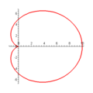

- x^{2/3}+y^{2/3}=4[(-3√3,1) (astroid)]

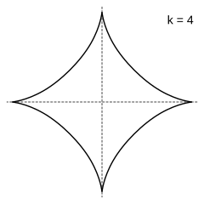
- 2(x² + y² )² = 25(x² - y²) [(3,1) (lemniscale)]
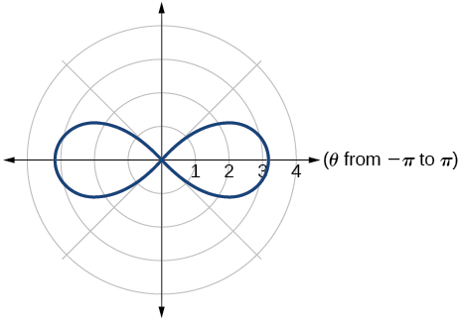

- y²(y²-4)= x²(x² -5) [(0,-2) (devils curve)]

